Developing and Supporting Student Leadership (DaSSL)
  - Reflection Tool and Action Plan
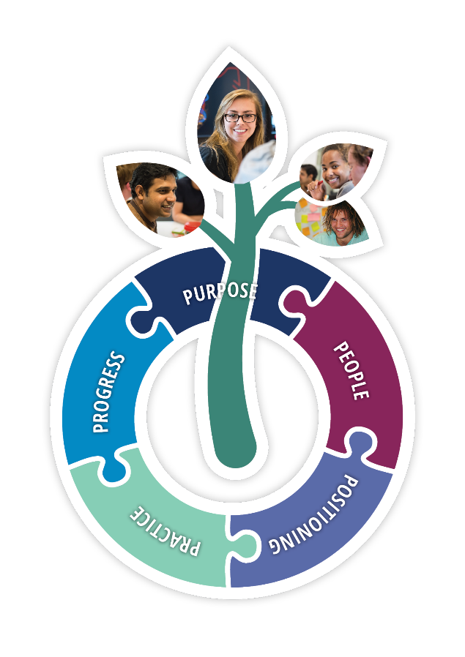
For more information about how to use this tool, visit the DaSSL project website: www.dassl.edu.au
This document has been developed by the DaSSL project team.
Support for this publication has been provided by the Australian Government Department of Education and Training.
Copyright (c) 2016 Commonwealth of Australia.
This work is licensed under a Creative Commons Attribution 4.0 International Licence.

Contents
Domain 1: Purpose 5
Reflection Questions 5
1.1 Key Drivers 5
1.2 Intended outcomes 5
1.3 Philosophical underpinnings 5
1.4 Evaluation 6
Action Plan 6
Evidence of Good Practice 6
Gaps Identified 6
Actions Planned 6
Expected Outcomes 7
Responsibilities 7
Resources and Support 7
Timeline 7
Domain 2: People 8
Reflection questions 8
2.1 Stakeholders 8
2.2 Recruitment & support 8
2.3 Reward & recognition 8
2.4 Evaluation 9
Action Plan 9
Evidence of Good Practice 9
Gaps Identified 9
Actions Planned 9
Expected Outcomes 10
Responsibilities 10
Resources and Support 10
Timeline 10
Domain 3: Positioning 11
Reflection questions 11
3.1 Institutional location 11
3.2 Strategic alliances 11
3.3 Resourcing & sustainability 11
3.4 Evaluation 12
Action Plan 12
Evidence of Good Practice 12
Gaps Identified 12
Actions Planned 12
Expected Outcomes 13
Responsibilities 13
Resources and Support 13
Timeline 13
Domain 4: Practice 14
Reflection questions 14
4.1 Planning and design 14
4.2 Implementation 14
4.3 Student leaders’ experience 14
4.4 Evaluation 15
Action Plan 15
Evidence of Good Practice 15
Gaps Identified 15
Actions Planned 15
Expected Outcomes 16
Responsibilities 16
Resources and Support 16
Timeline 16
Domain 5: Progress 18
Reflection questions 18
5.1 Program outcomes 18
5.2 Student leadership outcomes 18
5.3 Future opportunities 18
5.4 Evaluation 19
Action Plan 19
Evidence of Good Practice 19
Gaps Identified 19
Actions Planned 19
Expected Outcomes 20
Responsibilities 20
Resources and Support 20
Timeline 20

Domain 1: Purpose

Reflection Questions

1.1 Key Drivers
Why does our planned program need to exist at our institution?
What need or challenge will it meet?
How will it address institutional strategies?

1.2 Intended outcomes
What are we hoping to achieve with our program?
What leadership capabilities are we intending to develop?
How will the program address particular outcomes for equity /priority groups?
Are there other outcomes that the institution wants to achieve from this initiative?

1.3 Philosophical underpinnings
What does student leadership mean to us within our program or initiative?
Does this conceptualisation align with institutional goals?
How will the program support and celebrate diversity in leadership development?

1.4 Evaluation
How will we measure success in relation to the purpose of our program?

Action Plan

Evidence of Good Practice
What are we doing well and how do we know?

Gaps Identified
What needs strengthening?

Actions Planned
What are we going to do about it? How will we share our good practice?

Expected Outcomes
What do we expect to change?

Responsibilities
Who is responsible for taking action?
Who do we need to involve?

Resources and Support
What is needed and what is available?

Timeline
When will our actions be completed?

Domain 2: People

Reflection questions

2.1 Stakeholders
How will we engage with our internal and external stakeholders?
Who are our stakeholders and how will they have input?
What will be their roles and responsibilities?

2.2 Recruitment & support
How will we select and support our student leaders and program coordinators?
How will we ensure and support inclusivity and diversity in our recruitment processes and student leader training programs?
What skills and/or experiences will they need?
What support and training or professional development will be provided for them?

2.3 Reward & recognition
How will student leaders be recognised and rewarded in our program?
In what ways will the institution formally recognise and reward our student leaders?
What opportunities exist for reward and recognition external to the institution?

2.4 Evaluation
How will we assure that our program is engaging the most appropriate people to achieve our program's goals?

Action Plan

Evidence of Good Practice
What are we doing well and how do we know?

Gaps Identified
What needs strengthening?

Actions Planned
What are we going to do about it? How will we share our good practice?

Expected Outcomes
What do we expect to change?

Responsibilities
Who is responsible for taking action?
Who do we need to involve?

Resources and Support
What is needed and what is available?

Timeline
When will our actions be completed?

Domain 3: Positioning

Reflection questions

3.1 Institutional location
Where will our program sit in the organisational structure of the institution?
Will it be centrally-located or faculty-based, embedded in academic curriculum, co-curricular or extra-curricular?
How will we purposefully align our program with other student leadership opportunities within the institution?

3.2 Strategic alliances
Who will be our champions and how are they positioned across the institution?
How will the program authentically engage with equity and priority groups?
What will help us to position our program strategically?
How will the learning outcomes be formally recognised by the institution?

3.3 Resourcing & sustainability
What are the funding arrangements for our program?
How will these funding arrangements impact on the structure, function, resourcing and sustainability of the program?
What strategic connections could we leverage to build sustainability?

3.4 Evaluation
How might the positioning of our program impact on our ability to achieve success?

Action Plan

Evidence of Good Practice
What are we doing well and how do we know?

Gaps Identified
What needs strengthening?

Actions Planned
What are we going to do about it? How will we share our good practice?

Expected Outcomes
What do we expect to change?

Responsibilities
Who is responsible for taking action?
Who do we need to involve?

Resources and Support
What is needed and what is available?

Timeline
When will our actions be completed?

Domain 4: Practice

Reflection questions

4.1 Planning and design
How will we align our program design with our stated purpose and philosophy?
Who will be involved in planning and design decisions?
How will we ensure quality student engagement in the planning and design stage?
How will we plan for and design student leadership development opportunities within our program?

4.2 Implementation
How will we support student leadership development opportunities through our program?
What activities will be core to or characteristic of the program?
How will these activities contribute to developing student leadership?
How will we build a culture of inclusivity in our program?
What constraints and/or risks might we encounter in implementing this program?
How could we mitigate these?

4.3 Student leaders’ experience
How will we assist students to recognise and evidence their leadership development?
How will student leaders record their leadership development? What opportunities for reflection on experience will we build into the program?
How will the program take account of the experiences that student leaders bring?

4.4 Evaluation

What steps will we take to ensure continuous improvement in the design and delivery of our program?

Action Plan

Evidence of Good Practice
What are we doing well and how do we know?

Gaps Identified
What needs strengthening?

Actions Planned
What are we going to do about it? How will we share our good practice?

Expected Outcomes
What do we expect to change?

Responsibilities
Who is responsible for taking action?
Who do we need to involve?

Resources and Support
What is needed and what is available?

Timeline
When will our actions be completed?

Domain 5: Progress

Reflection questions

5.1 Program outcomes
How will we collect evidence of the effectiveness of our program?
How do we define effectiveness? How does this connect with institutional strategic objectives?
How will we assess the impacts of the program on the intended beneficiaries, especially equity/priority groups?
How will we communicate the outcomes of our program to inform decision-making and to persuade stakeholders?

5.2 Student leadership outcomes
What leadership capabilities do we expect to be developed by the students who participate in our program?
How will these be assessed? How will they contribute to organisational strategic goals and/or graduate employability?
What follow-up will we do with leaders and/or employers to ascertain the impact on their future pathways?

5.3 Future opportunities
What potential might the program have for expansion or further capacity-building?
What might be the possibilities for sustainable scaling-up? What would this take?

5.4 Evaluation
How do we plan to evaluate the extent to which our program has delivered on our stated objectives?
How will we ensure that we have access to all the relevant information to demonstrate effectiveness and quality?

Action Plan

Evidence of Good Practice
What are we doing well and how do we know?

Gaps Identified
What needs strengthening?

Actions Planned
What are we going to do about it? How will we share our good practice?

Expected Outcomes
What do we expect to change?

Responsibilities
Who is responsible for taking action?
Who do we need to involve?

Resources and Support
What is needed and what is available?

Timeline
When will our actions be completed?

